EXPERIMENT 8
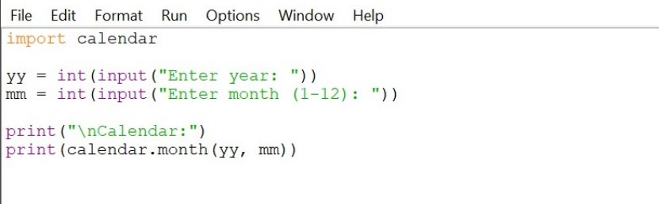
OUTPUT
